S.NO | NAME | DESIGNATION | QUALIFICATION, AWARDING AUTHORITY  WITH YEAR OF AWARD | DATE OF BIRTH | REG. NO. AND DATE OF REGISTRATION WITH NAME OF COUNCIL /BOARD | EXPERIENCE IN TEACHING CADRE AND DURATION AND NAME INSTITUTION WHERE SUCH EXPERIENCE GAINED | PHOTO
1. | DR. UPENDRA KUMAR VERMA | PRINCIPAL | DHMS 1986 BRA B.U M.D. (HOM.) 2004 MARATHWADA UNIV. MAHARASHTRA | 05/07/1963 | 23576 DT 16/01/1990 BIHAR STATE BOARD OF HOM. MED. | DEMONS. 06/3/1991 TO 21/8/1995, LECT. FROM 22/8/95 TO 2/8/1999 READER 03/8/99 TO 05/09/2001 IN BHMCH, PATNA AND AT GDMHMCH READER FROM 6/9/2001 TO 13/10/2003 , PROF. SINCE 14/10/2003 and  Principal Since 06/02/2025 AT GDMHMCH | 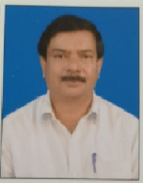

S.NO | NAME | DESIGNATION | DEPARTMENT | FT/GF | QUALIFICATION, AWARDING AUTHORITY  WITH YEAR OF AWARD | DATE OF BIRTH | REG. NO. AND DATE OF REGISTRATION WITH NAME OF COUNCIL /BOARD | EXPERIENCE IN TEACHING CADRE AND DURATION AND NAME INSTITUTION WHERE SUCH EXPERIENCE GAINED | PHOTO
1 | DR. DANISH | PROFESSOR | PRACTICE OF MEDICINE | FT | BHMS 1998 BRA BIHAR UNIVERSITY  M.D. (HOM.) 2013, BRA BIHAR UNIVERSITY | 24/01/1972 | 26421 DT 05/01/2001 BIHAR STATE BOARD OF HOM. MED., BIHAR | APPOINTED PROVSIONALLY AS LECTURER IN THE DEPT. OF PRACTICE OF MEDICINE FROM 20/01/2006 TO 31/10/2013AND AFTER PASSING M.D. (HOM.) SESSION 2010-2013  FROM GDMHMCH – FINALLY LECTURER FROM 01/11/2013TO 30/06/2019 AND READER FROM 01/07/2019 TO 31/08/2023 AND PROFESSOR SINCE 01/09/2023 | 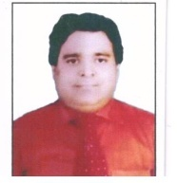
2 | DR. ARUN KUMAR SINGH | PROFESSOR | PRACTICE OF MEDICINE | FT | DHMS 1985 BRA BIHAR UNIVERSITY | 20/2/1963 | 25297 DT 21/8/1995  BIHAR STATE BOARD OF HOM. MED. | DEMONS. 25/11/95 TO 04/5/19999 LECT. 5/5/1999 TO 31/3/2006 , READER 1/4/2006 to 29/9/2012 BHMCH, PATNA . READER FROM 1/10/2012 TO 31/03/2025 AND PROFESSORE SINCE 01/04/2025 AT GDMHMCH,PATNA | 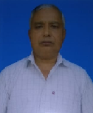
3 | DR. SIDDHARTH SINGH | ASSOCIATE PROFESSOR | PRACTICE OF MEDICINE | FT | BHMS 2014, VARKATULLA UUNIVERSITY, BHOPAL  M.D. (HOM.) 2019, BRA BIHAR, UNIV. | 03/03/1991 | 33633 DT 11/05/2020 BOARD OF HOM. MED., BIHAR | ASSISTANT PROFESSOR SINCE 01/01/2020 AT GDMHMCH AND ASSOCIATE PROFESSOR SINCE 17/03/2025 | 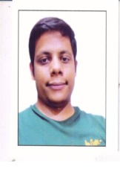
4 | DR. RAJAT DWIVEDI | ASSISTANT PROFESSOR | PRACTICE OF MEDICINE | FT | BHMS 2016 BRA BIHAR UNIVERSITY  M.D. (HOM.) APRIL. 2022, BRA BIHAR UNIVERSITY | 09/01/1994 | 32865 DT 12/01/2019 BOARD OF HOM. MED., BIHAR | ASSISTANT PROFESSOR SINCE 01/05/2022 AT GDMHMCH | 
5 | DR. RAM PRAWESH SHAH | PROFESSOR | HOM. PHARMACY | FT | DHMS 1991 BIHAR UNIVERSITY | 10/12/1964 | 24643 DT 7/8/1992 BIHAR STATE BOARD OF HOM. MED. | DEMONS. IN THE DEPT. OF PHARMACY FROM 16/09/1992 TO 12/10/1995,LECTURER 13/10/1995 TO 30/09/2011 BHMCH, PATNA READER FROM 1/10/2011 TO 31/08/2023 AND PROFESSOR SINCE 01/09/2023 AT GDMHMC, PATNA | 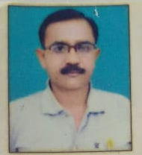
6 | DR BRIJ MOHAN PRASAD | ASSOCIATE PROFESSOR | HOM. PHARMACY | FT | BHMS 2012 - BRA BU, MD (HOM) 2021- BRA BU | 18/03/1984 | 30979 DT 20/05/2014, BIHAR STATE BOARD OF HOM. MED. | ASSISTANT PROFESOR SINCE 01/03/2021 IN GDMHMCH AND ASSOCIATE PROFESSOR SINCE 01/03/2025 | 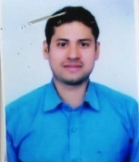
7 | DR. ARUN SINGH | ASSISTANT PROFESSOR | HOM. PHARMACY | FT | BHMS 2016 BRA BIHAR UNIVERSITY  M.D. (HOM.) . 2022 BRA BU | 05/11/1995 | 32782 DT 09/08/2018 BIHAR STATE BOARD OF HOM. MED | ASSISTANT PROFESSOR AT GDMHMCH SINCE 01/05/2022 | 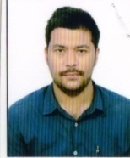
8 | DR. REENA KUMARI | ASSITANT PROFESSOR | HOM. PHARMACY | FT | BHMS, -2018  BRA BIHAR UNIVERSITY, M.D (HOM.) 2021 BRA BU | 12/03/1986 | 32791 DT 21/08/2018 BIHAR STATE BOARD OF HOM. MED. | ASSISTANT PROFESSOR SINCE 01/01/2024 IN GDMHMCH | 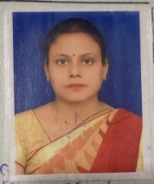
9 | DR. ANWARUL HASAN | PROFESSOR | HOM. MATERIA MEDICA | FT | BHMS 1996 BRA BIHAR UNIVERSITY, MD (HOM.) JRN RAJASTHAN | 1/7/1970 | 25948 DT 8/1/1999 BIHAR STATE BOARD OF HOM. MED. | DEMONS. FROM 15/1/99 TO 18/2/2002 LECT. FROM 19/2/2002 TO 1/4/2002 IN BHMCH, PATNA  IN GDMHMC AS LECTURER SINCE 02/04/2002 TO 2/6/2010 READER FROM 3/6/2010 TO21/12/2014 PROF SINCE 22/12/2014 | 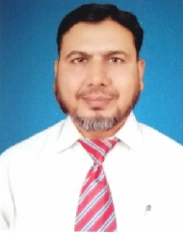
10 | DR. SAFI AHMAD | PROFESSOR | HOM. MATERIA MEDICA | FT | BHMS 2003, UNIV. OF ALCUTTA  MD HOM.) 2013 BRA BIHAR UNIVERSITY | 4/12/1978 | 29031 DT 15/3/2010 BIHAR STATE BOARD OF HOM. MED. | - LECTURER AT GDMHMCH FROM 16/11/2015 TO 19/11/2019, READER FROM 20/11/2019 TO 31/08/2023 AND PROFESSOR SINCE 01/09/2023 | 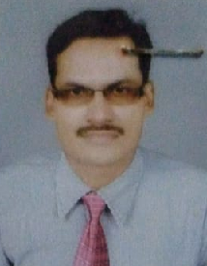
11 | DR. SRI PRAKASH SINGH | ASSOCIATE PROFESSOR | HOM. MATERIA MEDICA | FT | BHMS 2011 BRA BIHAR UNIVERSITY  M.D. (HOM.) 2017 BRA BU | 25/06/1988 | 33558 DT 13/01/2020 BIHAR BOARD OF HOM. MED. | LECTURER AT DR. HALIM H.M.C.H., DARBHANGA FROM 16/06/2017 TO 30/09/2019  LECTURER AT GDMHMCH FROM 01/10/2019 TO 31/8/2021 ASSOCIATE PROFESSOR SINCE 01/09/2021 | 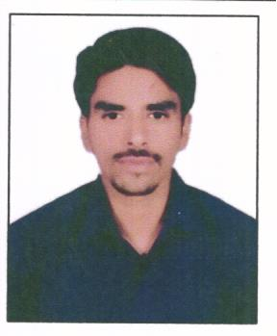
12 | DR. PRATIBHA RASTOGI | ASSOCIATE PROFESSOR | HOM. MATERIA MEDICA | FT | BHMS 2015 DR. BHIMRAO AMBEDKAR UNIVERSITY AGRA  M.D. (HOM.) 2021 BRA BIHAR UNIVERSITY | 10/07/1990 | 202339 DT 08/06/2016 CENTRAL COUNCIL OF HOMOEOPATHY. 202339 | LECTURER IN GDMHMCH FROM 08/04/2021 TO 30/06/2025 AND ASSOCIATE PROFESSOR SINCE 01/07/2025 | 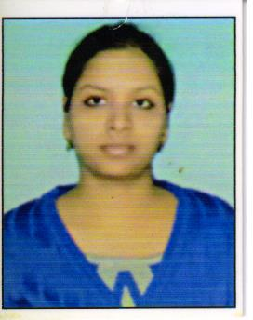
13 | DR. GHAZALA MUSARRAT | ASSISTANT PROFESSOR | HOM. MATERIA MEDICA | FT | BHMS 2017 BRA BIHAR UNIVERSITY  M.D. (HOM.) 2023 BRA BIHAR UNIVERSITY | 03/01/1995 | 33097 DT 3/9/2019 BIHAR STATE BOARD OF HOM. MED. | LECTURER AT GDMHMCH SINCE 01/08/2023 | 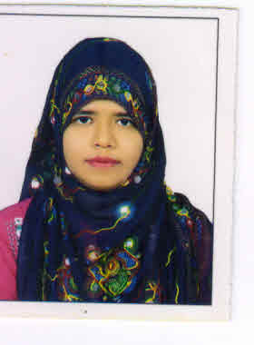
14 | DR. RAVINDER KUMAR VERMA | PROFESSOR | ORGANON OF MEDICINE | FT | DHMS 1987  BRA BIHAR UNIVERSITY | 30/6/1964 | 23444 DT 31/8/1989 BIHAR STATE BOARD OF HOM. MED. | DEMONS – 15/5/1995 TO 16/7/2001, LECTURER FROM 17/7/2001 TO 20/8/2006 READER FROM 21/8/2006 TO 19/9/2012 IN BHMCH AND IN GDM HMCH READER FROM 20/9/2012 TO 31/08/2023 AND PROFESSORE SINCE 01/09/2023 | 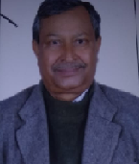
15 | DR. SHUBHRA KUMARI | ASSOCIATE PROFESSOR | ORGANON OF MEDICINE | FT | BHMS 2009 BRA BIHAR UNIVERSITY, M.D. (HOM.) 2016 BRA BIHARUNIVERSITY | 22/6/1987 | 29761 DT 11/7/2011 BIHAR STATE BOARD OF HOM. MED. | LECTURER IN GDMHMC –PATNA FROM 03/4/2017 TO 31/08/2021 AND ASSOCIATE PROFESSOR SINCE 01/09/2021 | 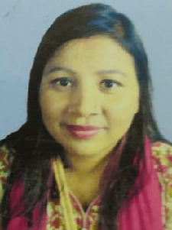
16 | DR. GUNJAN KUMAR | ASSISTANT PROFESSOR | ORGANON OF MEDICINE | FT | BHMS 2013, BRA BIHAR UNIVERSITY  M. D. (HOM.) DEC.2020 BRA BIHAR UNIVERSITY | 28/02/1988 | 31036 DT. 27/05/2014 BIHAR STATE BOARD OF HOM. MED. | AT G. D. MEMORIAL HOM. MEDICAL COLLEGE AND HOSPITAL SINCE 01/08/2021 | 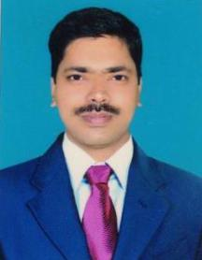
17 | DR. KRISHNA MURARI | ASSISTANT PROFESSOR | ORGANON OF MEDICINE | FT | BHMS 2016- BRA BIHAR UNIVERSITY,  MD. (HOM)- 2021,  MAHARASTRA UNIVERSITY OF HEALTH SCIENCES, NASIK | 16/09/1990 | 32650 DT 04/07/2018 BIHAR STATE BOARD OF HOM. MED | ASSISTANT PROFESSOR SINCE 08/10/2022 IN GDMHMCH | 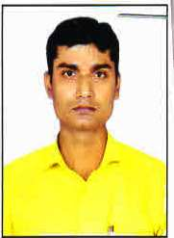
18 | DR. SANJIV KUMAR SINGH | PROFESSOR | REPERTORY | FT | BHMS 2005 The UNIVERSITY OF BURDWAN  M.D (HOM.) 2011 BRA BIHAR UNIV. | 5/1/1975 | 28001 DT 12/3/2007 BIHAR STATE BOARD OF HOM. MED. | LECTURER FROM 01/10/2011 TO 09/11/2015 READER FROM 10 /11/2015 TO 31/08/2021., AND PROFESSOR SINCE 01/09/2021 IN GDMHMC PATNA | 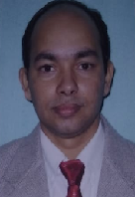
19 | DR. RAVI KUMAR | ASSOCIATE PROFESSOR | REPERTORY | FT | BHMS 2012 BRA BIHAR UNIVERSITY  M. D. (HOM.) 2018 BRA BIHAR UNIV. | 01/09/1989 | 30889 DT. 29/04/2014 BIHAR BOARD OF HOM. MED. | LECTURER IN GDMHMCH FROM 1/02/2019 TO 31/8/2023 AND ASSOIATE PROFESSOR SINCE 01/09/2023 | 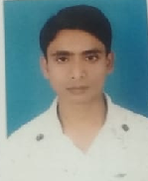
20 | DR. SUDHANSHU BHUSHAN SINGH | ASSISTANT PROFESSOR | REPERTORY | FT | BHMS 2016 – BRA BU, MD (HOM) 2021 – BRA BU | 12/02/1980 | 32740DT 26/07/2018, BIHAR STATE BOARD OF HOM. MED. | ASSISTANT PROFESOR SINCE 01/05/2022 IN GDMHMCH | 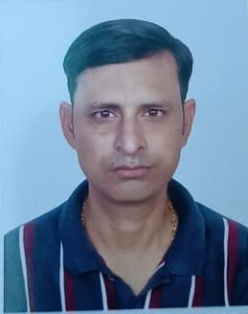
21 | DR. ANKITA SINGH | ASSISTANT PROFESSOR | REPERTORY | FT | BHMS 2017 – BRA BU, MD (HOM) 2023 – BRA BU | 14/11/1993 | 33500 DT 11/12/2019, BIHAR STATE BOARD OF HOM. MED. | ASSISTANT PROFESOR SINCE 01/09/2023 IN GDMHMCH | 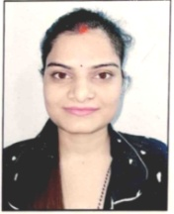
22 | DR. NILAM KUMARI SAHANI | PROFESSOR | PAEDIATRICS | FT | BHMS 1998 BRA BIHAR UNIV. MD. (HOM.) 2004 JRN RAJASTHAN VIDYAPEETH UNIV. | 25/4/1959 | 26948 DT 04/07/2002 BIHAR STATE BOARD OF HOM. MED. | LECTURER FROM 1/11/2007 TO 15/11/2011 READER FROM 16/11/2011 TO21/12/2014 AND PROFESSOR SINCE 22/12/2014 IN GDMHMCH ,PATNA | 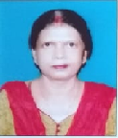
23 | DR. SACHCHIDAN-AND MISHRA | PROFESSOR | PAEDIATRICS | FT | BHMS 1993 BRA BIHAR UNIVERSITY | 01/01/1964 | 25745 DT 25/3/1983  BIHAR STATE BOARD OF HOM. MED. | DEMONS. FROM 10/11/98 TO 11/9/2005 LECTURER FROM 12/9/2005 TO 18/7/2011 READER 19/7/2011 TO 26/4/2012 IN BHMCH, PATNA AND IN GDMHMCH AS READER ROM 27/04/2012 TO 31/08/2021 AND PROFESSOR SINCE 01/09/2021 | 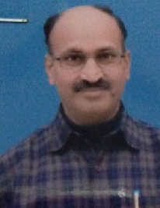
24 | DR. ABHAY KUMAR SINGH | PROFESSOR | PAEDIATRICS | FT | BHMS 2010 JRN RAJASTHAN V. UNIVERSITY  MD. (HOM.) 2014 BRA BIHAR UNIV | 1/2/2984 | 29881 DT 19/3/2011  BIHAR STATE BOARD OF HOM. MED. | LECTURER IN GDMHMCH FROM 2/1/2015 TO 31/01/2019  READER FROM 01/02/2019 TO 31/01/2019 AND PROFESSOR SINCE 01/07/2025 | 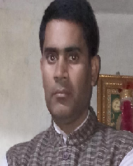
25 | DR. AKHILESHWAR ROY | ASSOCIATE PROFESSOR | PAEDIATRICS | FT | BHMS 2012 BRA BIHAR UNIVERSITY  M.D. (Hom.) 2021 BRA BIHAR UNIVERSITY | 15/09/1986 | 30836 dt 16/04/2014  BIHAR STATE OF HOM. MEDI. | ASSISTANT PROFESSOR AT GDMHMCH FROM 01/06/2021 TO 30/06/2025 AND ASSOCIATE PROFESSOR SINCE 01/07/2025 | 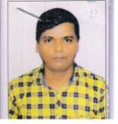
26 | DR. SHABANA PRAVEEN | ASSISTANT PROFESSOR | PAEDIATRICS | FT | BHMS 2018 BRA BIHAR UNIVERSITY  M.D. (Hom.) 2022 BRA BIHAR UNIVERSITY | 30/06/1996 | 33375 dt 18/10/2019  BIHAR STATE OF HOM. MEDI. | ASSISTANT PROFESSOR AT GDMHMCH SINCE 01/01/2024 AT GDMHMCH | 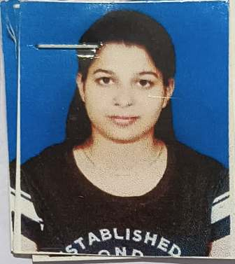
27 | DR. LAKSHAMAN SHARMA | PROFESSOR | PSYCHIATRY | FT | DHMS BRA BIHAR UNIVERSITY M.D. (HOM.) 2008 B.R AMBEDKAR UNIV., AGRA | 8/1/1961 | 22746 DT 11/1/1988  BIHAR STATE BOARD OF HOM. MED. | DEMONS. 13/9/94 TO 20/3/98,  LECT. FROM 21/3/98 TO 16/8/2004  READER FROM 17/8/2004-TO 12/5/2010. PROFESSOR FROM . 13/5/2010 TO 9/1/13  B.H.M.C.H , PATNA AND IN GDMHMCH, PATNA SINCE 10/1/2013 | 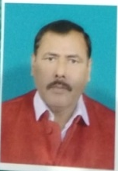
28 | DR. SUNIL KUMAR RAI | ASSOCIATE PROFESSOR | PSYCHIATRY | FT | BHMS 2002 BRA BIHAR UNIV. | 02/05/1968 | 27533 DT 29/5/2004  BIHAR STATE BOARD OF HOM. MED. | DEMONSTRATOR FROM 31/05/2004 TO 17/09/2008, LECTURER FROM 18/9/2008 TO 20/4/2012 AND READER 21/4/2012 TO 19/10/2012 AT BHMCH, PATNA, IN GDMHMCH SINCE 20/10/2012 AS READER | 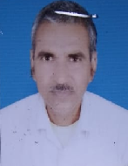
29 | DR. DEEP MALA | ASSISTANT PROFESSOR | PSYCHIATRY | FT | BHMS 2016 BRA BIHAR UNIVERSITY  M.D. (HOM.) 2020 BRA BIHAR UNIVERSITY | 15/11/1980 | 32412 DT 30/6/2017 BOARD OF HOM. MEDICINE, BIHAR | ASSISTANT PROFESSOR AT GDMHMCH SINCE 03/01/2022 | 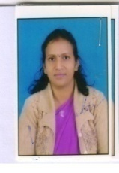
Department of Research Methodology and Biostatistics

1. | DR. RAVINDRA PANJIYAR | PROFESSOR | Research Methodology and Biostatistics | FT | BHMS (GRADED) 1985 BRA BIHAR UNIVERSITY  M.D. (HOM.) 2006  JRN RAJASTHAN VID. UNIVERSITY | 15/01/1961 | 20600 DT. 21/03/1983 BOARD OF HOMOEOPATHIC MEDICINE BIHAR | DEMONSTRATOR FROM 07/02/2001 TO 17/08/2005,  LECTURER 18/08/2005 TO 23/03/2010, READER FROM 24/03/2010 TO 20/11/2012 AT BHMCH, PATNA AND AT GDMHMC&H AS READER FROM 21/11/2012 TO 31/8/2023 AND AS PROFESSOR SINCE 1/09/2023 and Prof. in the Dept. of Research Methodology and Biostatistics from 25/06/2025 | 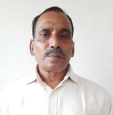
2. | DR RATAN LAL GUPTA | ASSOCIATE PROFESSOR | Research Methodology and Biostatistics | FT | BHMS 2014 – BRA BU, MD (HOM) 2021 – BRA BU | 15/10/1991 | 32137 DT 03/03/2017, BIHAR STATE BOARD OF HOM. MED. | ASSISTANT PROFESOR SINCE 01/03/2021 IN GDMHMCH AND ASSOCIATE PROFESSOR SINCE 01/04/2025 and Associate Prof. in the Dept. of Research Methodology and Biostatistics from 25/06/2025 | 